5.2 Building Continuous Integration Pipelines In Jenkins

This section will guide you to:
- Build Continuous Integration Pipelines in jenkins

This lab has two sub-sections, namely:
5.2.1 Building a Maven project
5.2.2 Creating a Pipeline to build the project

Step 5.2.1: Building a Maven project
- Login to your Github account.
- Click on the plus icon next to the profile picture and select New repository from the drop-down menu.
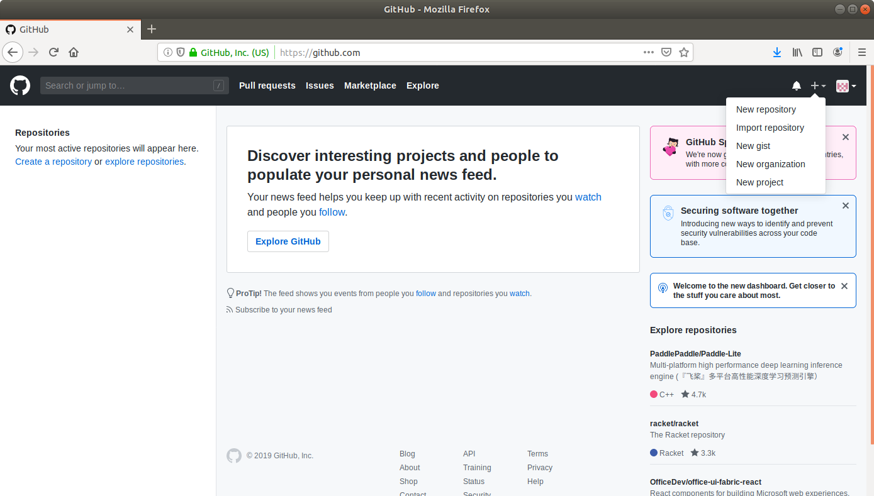

- Fill the required fields in the create repository form.
- Click on the Create Repository button.
- Click on the Clone or download button and copy the URL.
- Go to ​start.​spring.​io/​
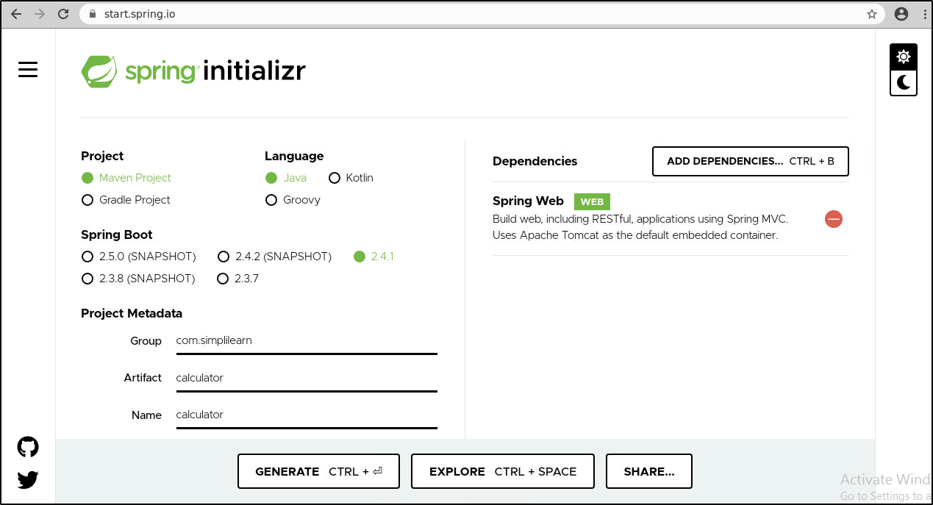
- Select Maven as the project type.
- Fill Group and Artifact with appropriate values. For example, com.simplilearn and Calculator.
- Add Web (Spring Web) to Dependencies.
- Select Packaging: Jar
- Select Java: 8
- Click on Generate Project.
- The generated skeleton project should be downloaded as a zip file.
- Open the terminal and navigate to an appropriate location.
- Run git clone [URL] to clone the repository.
- Unzip the downloaded spring boot project to the cloned repository.
(cd Downloads
unzip Calculator.zip)
- Copy the contents of Calculator folder present in downloads and paste it into your repository folder)
- Commit the changes to the remote SCM.
- Run git add .
- Run git commit -m “Add logic and test”
- Run git push -u origin master

Step 5.2.2: Creating a Pipeline
- Go to Jenkins dashboard.
- Click on New Item.
- Enter a name for your build job.
- Select Pipeline as the build job type.
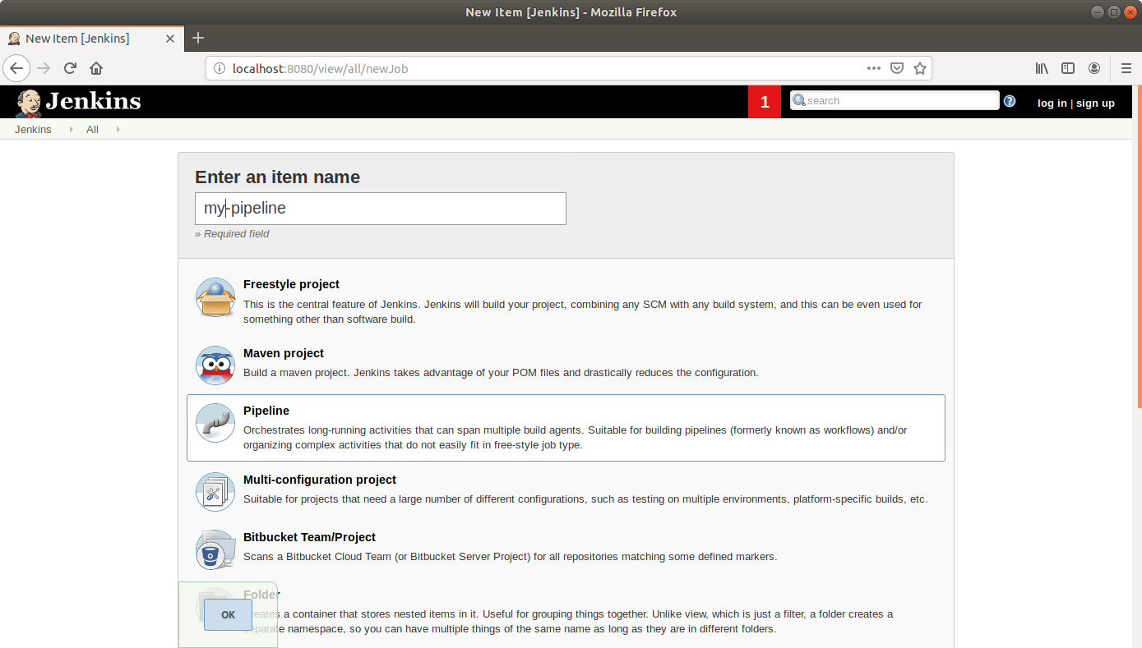
- Click OK.
- Scroll down to the Pipeline section and enter the script below:
pipeline {
agent any
tools {
maven 'my_mvn'
}
stages {
stage("Checkout") {
steps {
git url: '<YourGithubRepoURL>'

}
}
stage('Build') {
steps {
sh "mvn compile"
}
}

stage("Unit test") {
steps {
sh "mvn test"
}
}
}
}
- Click Save.
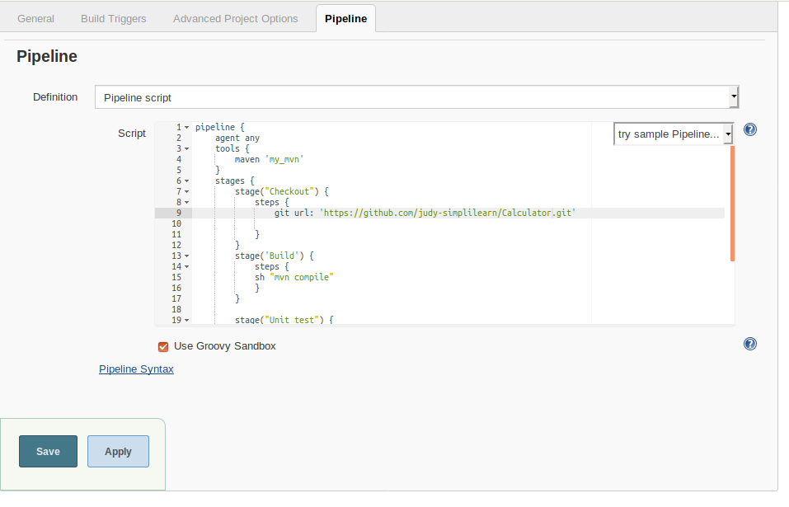
- Click Build Now in the project window to make sure that the build works. Jenkins will now build your project.
- Click on the Build History to view the build results.
- Click on the Logs to view the build logs in each stage.
